Software Development – Handong Timecode

Software Engineering term project

By

20800128, Yoon Tae Kim

21000013, Ji Hye Kang

21100723, Ye Seul Choi

21100690, Su Hyun Joo

Software Engineering

Fall 2013

Date Submitted: December 11, 2013

Table of Contents

1. Introduction
2. Performance Goal
3. Project Requirement Specification
4. Map Function
5. Project Group Management
6. Programming Language
7. Development Environment
8. Operating System
9. Project Design
10. System Modeling Diagram
11. User’s Manual
12. Installation Guide
13. Android Emulator
14. Actual Android device
15. Source Code(major function)

A.

B.

1. Test Case
2. Trial and Error
3. Future Direction
4. Conclusion

Appendix

References

1. Introduction
   1. Performance Goal

To implement a system that enables Handong students to efficiently keep and manage the time, specifically in doing their project meetings.

1. Project Requirement Specification
   1. Map Function

Provide users with the map within the Handong Global University. The base for the map is 23 buildings within it and the shortest path or to reach the destination measured and suggested to users.

* 1. Project Group Management

The function utilizes database system to store, load, revise, update, and delete the information about the project group upon user’s command. Any actions or changes to the system are as well informed to planner system so that the planner of the appropriate users can be updated. We use XAMPP to ensure running Apache and MySQL.

* 1. Programming Language

The program is implemented by utilizing Java language, xml, query.

* 1. Development Environment

The program is implemented based on eclipse, Android SDK, Apache and MySQL.

* 1. Operating System

The program run on Android, based on Linux OS kernel.

1. Project Design
   1. System Modeling Diagram
      1. Context Diagram

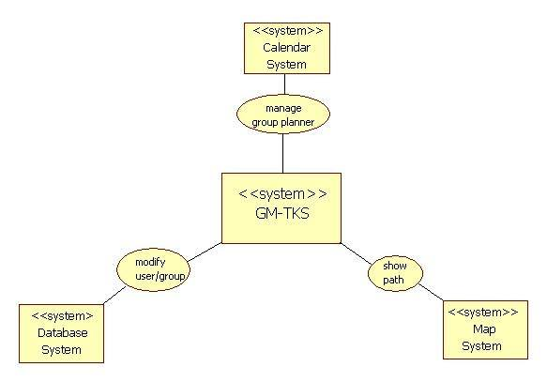

* + 1. Process Model Diagram

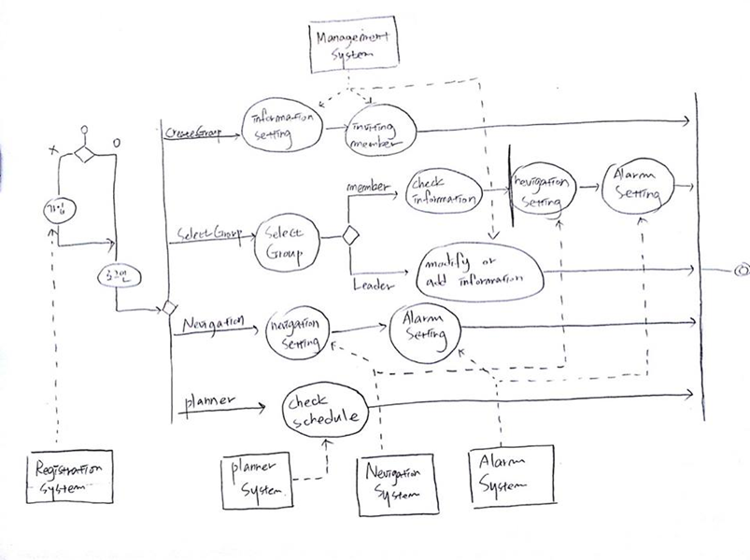

* + 1. Use case

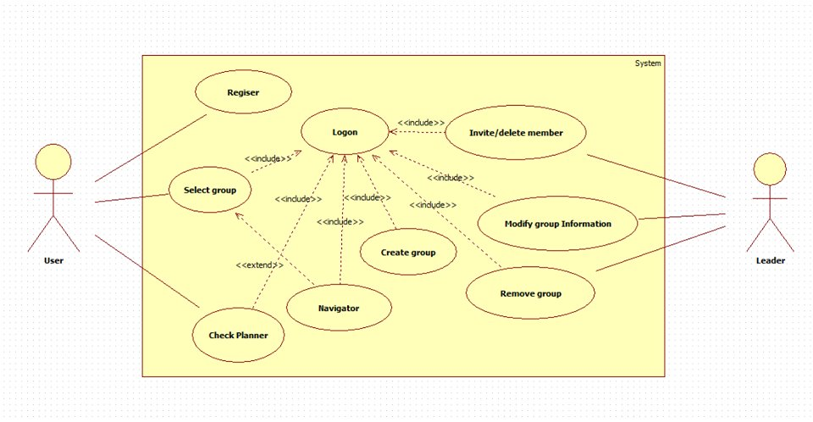

|  |  |  |  |
| --- | --- | --- | --- |
| **Use case : Register** | | | |
| **Actor** | User | | |
| **Precondition** | User must be unregistered | | |
| **Main scenario** | | | |
| **Input Events from Actor Customer** | | | **System Events and Responses** |
| Execute application, account is not registered yet | | | Display register page |
| Input ID | | | Check if the input ID already exists |
| Input personal information | | | Check if all the fields are filled |
| Register | | | Register |
| **Alternative Scenario** | | In case registered without input | |
| **Exceptional Scenario** | | In case ID redundancy was not confirmed by the user: Suggest the user to check the redundancy  Fill all the Personal Information Input field | |

|  |  |  |  |
| --- | --- | --- | --- |
| **Use case : Logon** | | | |
| **Actor** | User | | |
| **Precondition** | User must be registered and logged on | | |
| **Main scenario** | | | |
| **Input Events from Actor Customer** | | | **System Events and Responses** |
| Logon | | | Display a welcome message and request customer ID and password |
| Checking | | | Check if the ID and the Password is registered ones. |
| **Alternative Scenario** | | Attempt to log on without ID, Password | |
| **Exceptional Scenario** | | In case of unregistered member, suggest registration | |

|  |  |  |  |
| --- | --- | --- | --- |
| **Use case : Navigator** | | | |
| **Actor** | User | | |
| **Precondition** | 1. User must be registered and logged on 2. User must have gone through Log on -> Select Group state | | |
| **Main scenario** | | | |
| **Input Events from Actor Customer** | | | **System Events and Responses** |
| Selecting navigator | | | For the 1st case, page for setting departure place and destination place appears |
| Setting Departure place and Destination place | | | Shortest path is shown through the map and the traveling time is calculated and displayed as well. |
| **Alternative Scenario** | | No meeting exists: pop up that enables users to move to create group page appears | |
| **Exceptional Scenario** | | If the user sets the same departure place and destination place  : still display map page but with the value of 0 | |

|  |  |  |  |
| --- | --- | --- | --- |
| **Use case : Create new group** | | | |
| **Actor** | User | | |
| **Precondition** | User must be registered and logged on | | |
| **Main scenario** | | | |
| **Input Events from Actor Customer** | | | **System Events and Responses** |
| Select Create new group button in Main page. | | | Create group page appears |
| Insert information about group | | | Input group name, subject of the meeting., venue and announcement. Invite member and set the meeting time. |
| Create new group | | | New group is created with the information input. |
| **Exceptional Scenario** | | In case if not all the information is filled, suggest users to filled all of the vacant field | |

|  |  |  |  |
| --- | --- | --- | --- |
| **Use case : Invite member** | | | |
| **Actor** | Leader | | |
| **Precondition** | Must be logged on registered user and he/she can only access to group that he/she created.  User must have gone through login -> create group process | | |
| **Main scenario** | | | |
| **Input Events from Actor Customer** | | | **System Events and Responses** |
| Select Invite member button from create group page | | | Show list of groups available |
| Select members to invite | | | Radio checks the members selected, multiple choice is allowed |
| Push invite button | | | Name of the selected person is sent and displayed to calling display page and finally saved in DataBase when create group is completed |
| **Alternative Scenario** | |  | |

|  |  |  |  |
| --- | --- | --- | --- |
| **Use case : Select group** | | | |
| **Actor** | User | | |
| **Precondition** | User must be logged in and registered member. | | |
| **Main scenario** | | | |
| **Input Events from Actor Customer** | | | **System Events and Responses** |
| Select Select group button | | | List of available groups are displayed |
| Select particular group to see the information | | | Group information is displayed in pop up dialog. Meeting venue, time and announcements are shown |
| **Alternative Scenario** | | In case no group exist | |

* + 1. Sequence diagram

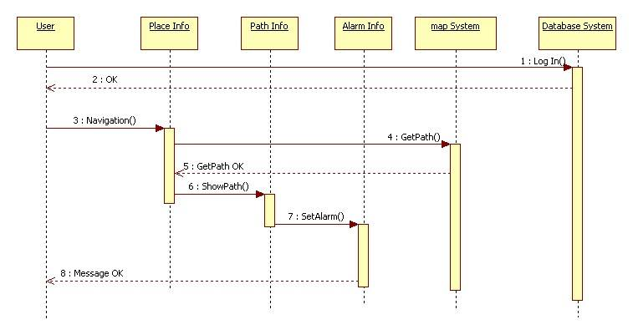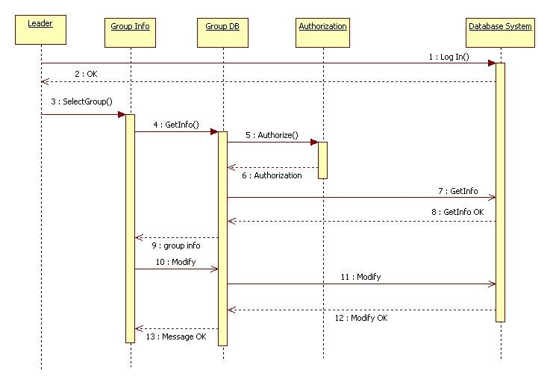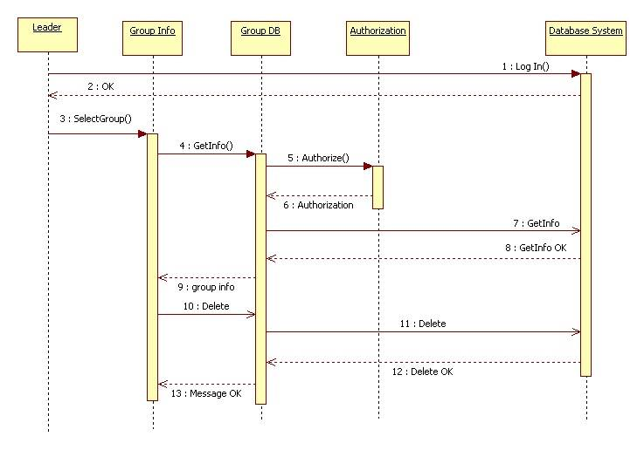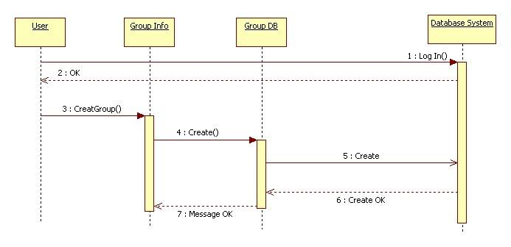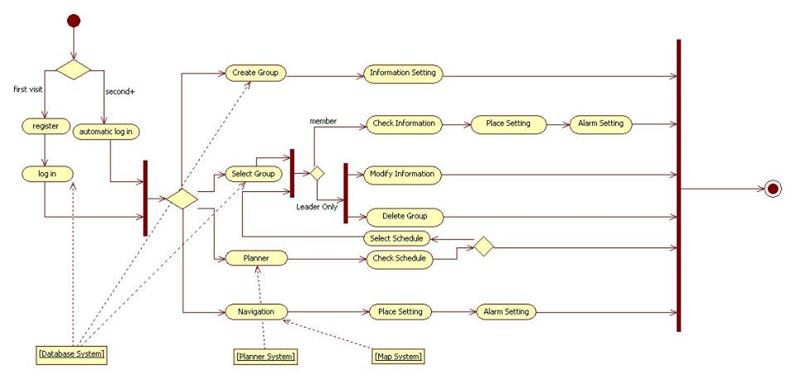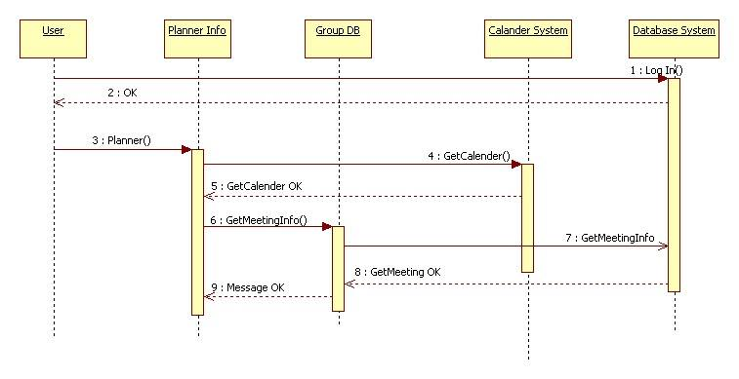

* + 1. Data Flow Diagram

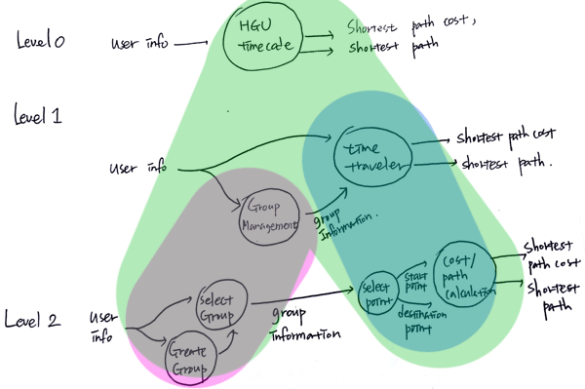

1. User’s manual

|  |  |
| --- | --- |
| Image | Manual |
| Screenshot_2013-12-10-23-41-54.png  <Loading page> | Loading Activity:  Loading image appears with the logo of the application. When the user touches the screen, the login/register selection page appears |
| C:\Users\Su\Desktop\보고서용UI\크기변환_intro.png  <Entrance page> | Entrance Menu Activity:  Entrance page appears and user may choose between registering and logging in according to the user’s current registration state |
| Screenshot_2013-12-10-23-46-40.png  <Log-In page> | Log-in Activity:  If the user is already a registered user, input id and password. Once the log-in is successful, the main menus(4)Menu) appears |

|  |  |
| --- | --- |
| Screenshot_2013-12-10-23-43-53.png  <Registration page> | Registration activity:  If the user is an unregistered user, input personal information including id, student number password and phone number to register. If the user completely fills the fields and press register button, log in is automatically done and the state goes to 4) Menu |
| Screenshot_2013-12-10-23-46-52.png  <Main Menu page> | Main menu Activity:  If the user is successfully logged on, the main page appears and the user may choose from |

|  |  |
| --- | --- |
| Screenshot_2013-12-10-23-47-27.png  <Create Group Page> | CreateGroup Activity:  The page appears when Create Group button is pressed in main menu page. User can set the group name, subject name in the text field. User can set the meeting and invite members by pressing the designated button. |
| Screenshot_2013-12-10-23-48-25.pngScreenshot_2013-12-10-23-48-47.png  <Set Meeting Page> | Set Meeting Activity:  User can set the date and the time of the meeting by clicking the fields. Venue and the announcements can be typed in as well. User completes setting meeting by clicking the set button and the page returns to previous create group page. In the list view below the set meeting button, the list of meetings are added. |

|  |  |
| --- | --- |
| Screenshot_2013-12-11-02-45-46.pngScreenshot_2013-12-11-00-17-02.png  Screenshot_2013-12-11-00-30-42.pngScreenshot_2013-12-11-02-45-36.png  < Select Group page> | Select Group page:  When select group button is pressed,  list of groups that user is in appears. If the user presses the group, and the meeting information exists, another page showing the venue of the meeting appears. If the users presses the venue, the information about the meeting appears. If a group does not have meetings yet, and the user selects that group, the toast message appears and inform the user that there exists no information |

|  |  |
| --- | --- |
| Screenshot_2013-12-10-23-49-34.png  <Time Traveler page > | Time Traveler Activity:  The page is loaded when the time traveler button is pressed in the main page. The start point, where the user will depart and the destination point, the meeting venue, can be selected. |
| Screenshot_2013-12-10-23-49-55.png  <Map page> | Map Activity:  If the user presses ok button the shortest path to the destination is shown in the map as well as the required time to reach the venue. |

1. Installation guide
   1. Android Emulator

Import the project’s package to eclipse

File - Import

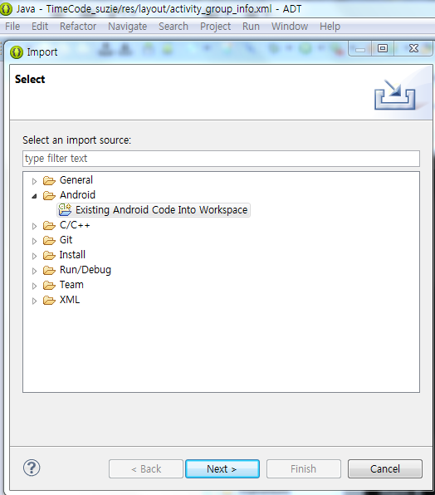

Select Existing Android Code Into Workspace -> Next

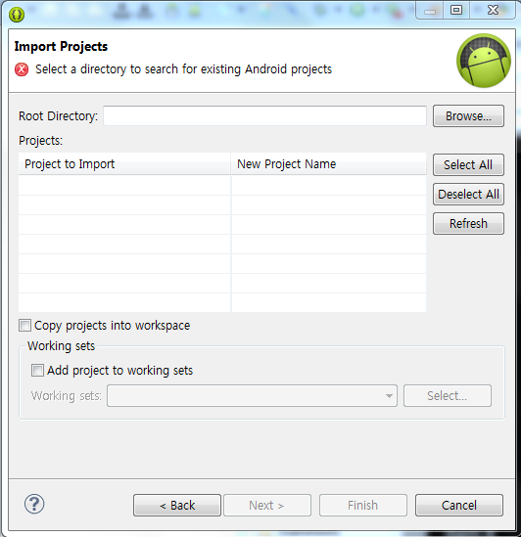 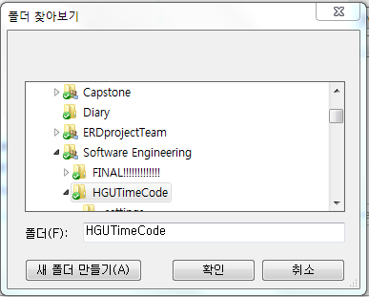

Browse – Select the folder with the package to import

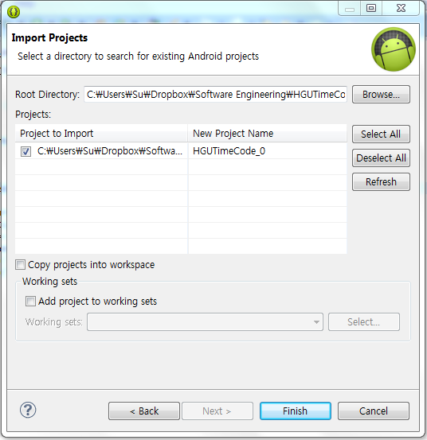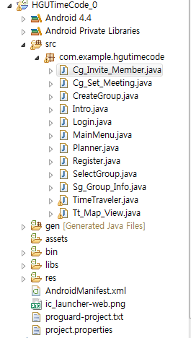

If Finish is selected, the imported package appears in the eclipse packages.

Install the application virtually using Android Emulator. If the Emulator is not available, select create new AVD and install appropriate AVD that fits the application

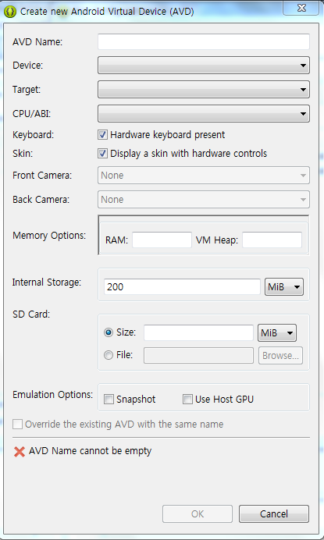

Execution of Emulator. Application works according to the user’s manipulation.

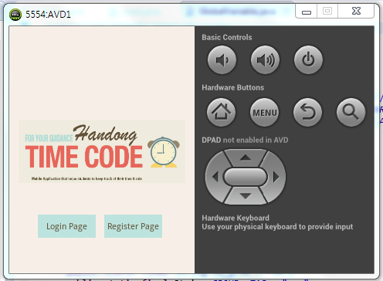

* 1. Actual Android device

Download timcode.apk file in Bin folder of the project and intall it on the device

1. Source code
   1. Time Traveler

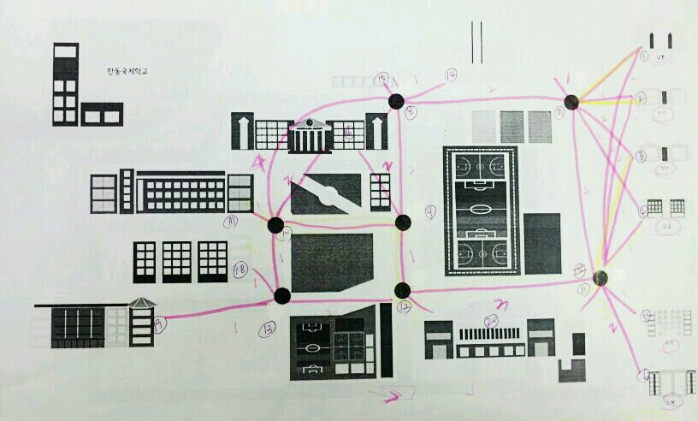

Internal map of Handong Global University. Path is formed based on the map and the indicated numbers are index to the nodes

* + 1. TimeTraveler.java

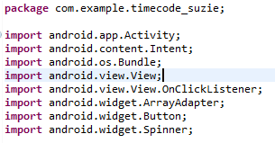

Import necessary package and the class

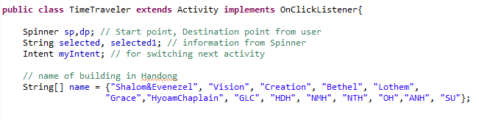

Contents of TimeTraveler class. Neede variables are declared and the names of the buildings that can be set as start poin and destination point is declared in array with name ‘name’. Activity class is extended and the OnClickListener to handle the button events are implemented as well.

1. onCreate

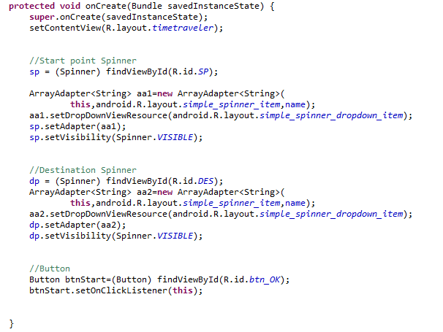

Since TimeTraveler is the sub class of Activity Class, that the OnCreate method is automatically called when it is executed. OnCreate method creates activity prints out the layout of timetraveler.xml on the screen.

Create spinners named sp and dp. String array ‘name’ with the names of the building is got through the array adapter aa1 and aa2 and the setAdapter method is used to set the list as a list of selections on the spinners, then, set VISIBLE

Create Button,

Button is created and setOnClickListener is used to set the Button so that the onClick method is called when the button is clicked.

1. onClick

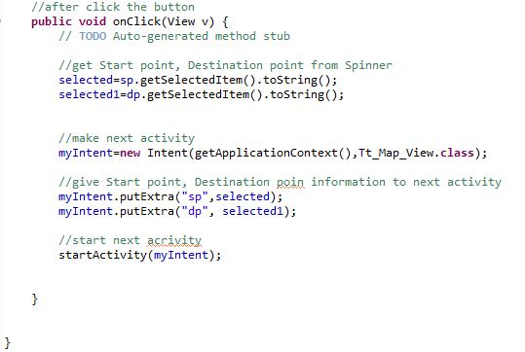

onClick method is a method that handles events when they occurs. If the button is pressed, this method is called and executed. The method brings the name of the building selected through spinners sp and dp. Create Intent so that it can be converted to Tt\_Map\_View.class and the values of sp and dp is sent to the class to be used. The next class is executed.

* + 1. Tt\_Map\_View.java

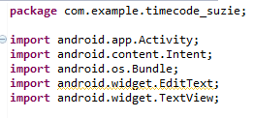

Import necessary packages and classes

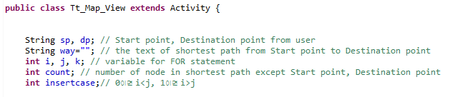

Contents of the Tt\_Map\_View class. Necessary variables are declared and the explanations are included as comments. Explanation about the insert case is included in the explanation on onCreate function.

1. onCreate

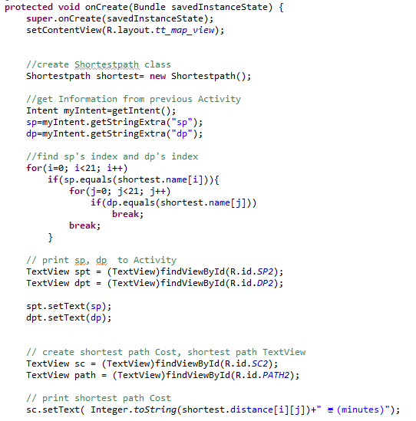

Create shortestpath class. As the class is created, all the shortest paths from each node to each other node is computed. Receive values of sp and dp from the previous acitivty and find the index of them using for loop.

Create textview on start point, destination point, shortest path cost, and shortest path. Place values of sp and dp in start point와 destination point, shortest path cost and the cost of the shortest path is received from the created shortest path class.

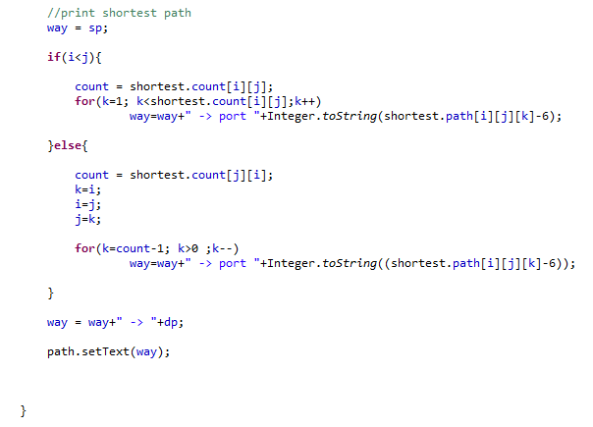

way is the string of the to be printed shortest path. Input the start point and if i<j, get the calculated values from the class, and if i>j, reverse the path that is used when i<j and inputted. Through for loop, the input continues until k reaches the number of path count. When inputting, the value is concatenated at the back of the previous input string. If the input is done, the destination point is inputted as the last input.

1. shortest path class ( subclass )

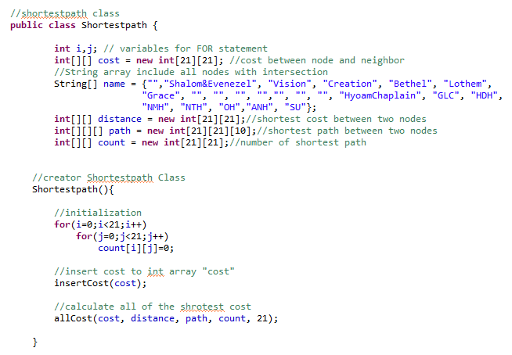

Comment shows the explanation on the variable. Input cost through shortestpath’s constructor,, shortestpath, calculate the shortest path cost and get the shortest path.

b-1) insertCost

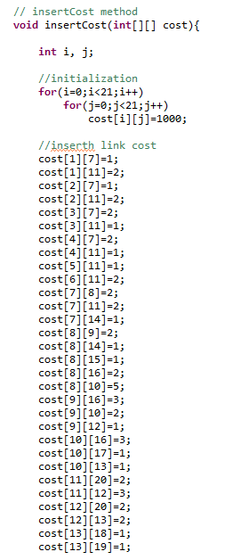

Value must be infinite before the input exists that the value is initialized with value 1000, and the rest of them is initialized with default values.

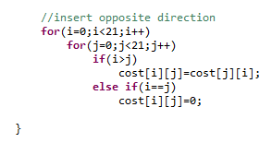

Input for the i>j case using for loop.

b-2. allCost

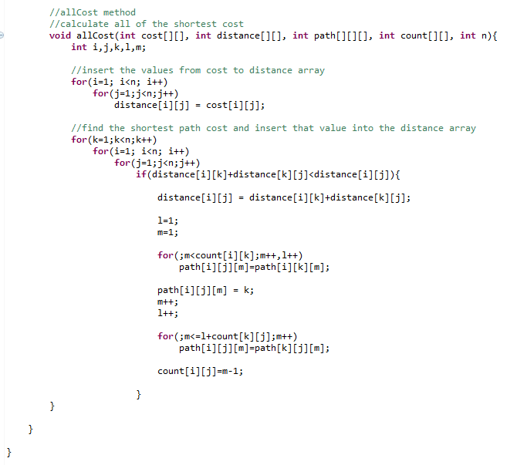

Method of getting shortest path cost and shortest path from every node to every other node. At first, move values of the cost array with the values of every link’s cost to distance array. Then, using all pair data structure algorithm, find shortest path costs and the shortest path is found using extra code added by the developer.

* 1. DB and Server

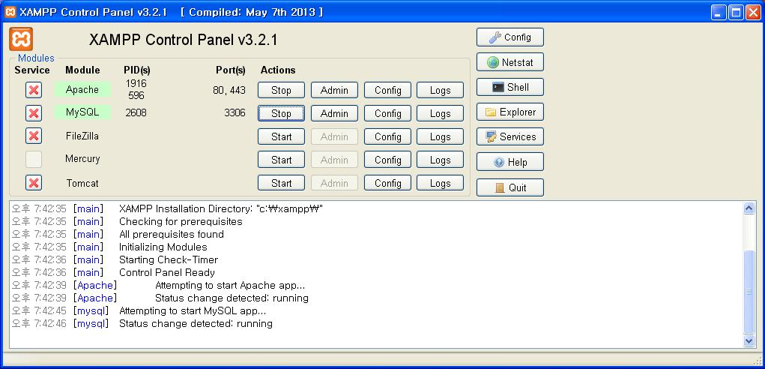

Handong Timecode uses Apache as server. XAMPP is a cross-platform web server solution stack package. The project used XAMPP to control Apache, MySQL and PHP together to create a web server in personal computer.

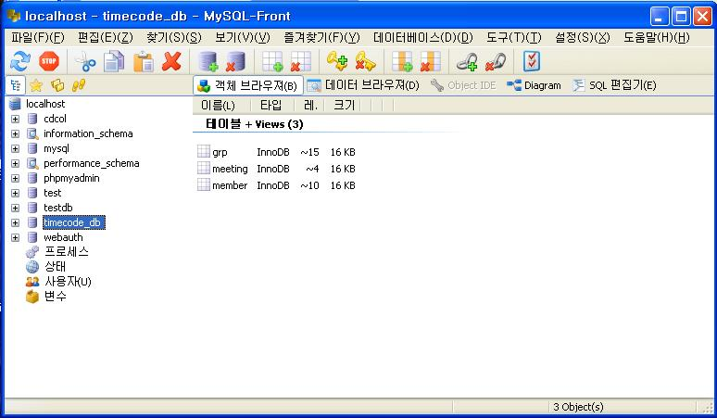

MySQL-Front is a client for Windows that allows the management to manage a local or remote DB through a client interface. With this tool, database can be managed from the windows, and values can be observed from console window.

Android file send query to the server and query gets to the DB via PHP.

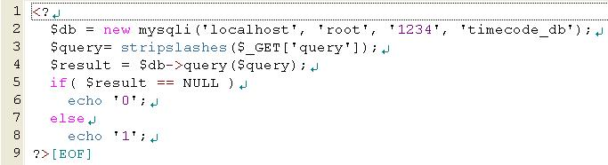

This is nonqueryExecutor.php . It is used when queries such as ‘INSERT’ or ‘DELETE’ is used. In other word, when there is no response wanted.

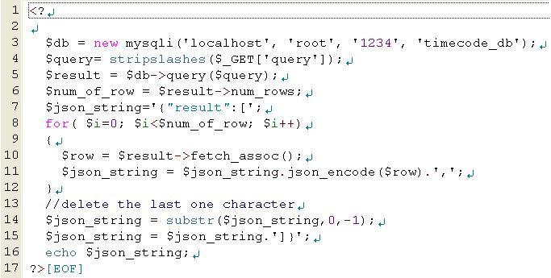

This is queryExecutor.php. It is used when queries such as ‘SELECT’ is used. In other word, when program expect response message to take care of.

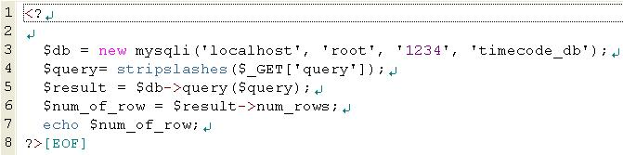

This is queryExecutor\_login.php. It is used only in the login system. It returns the number of items the query asked. It will return 0 if there is no such information. Otherwise, it will return.

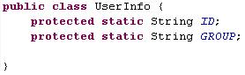

This is UserInfo class. It has ID and GROUP variable and stores user’s id value and GROUP value. It is saved as static value that it is reachable from every class.

Actual code of sending data to the database requires several steps. First, query must be set in the form of url to be transferred to the php file. After that, php file sends query to the MySQL. If response exists, php sends it to the application. JSON is used to get the response and deal with it.

There are three cases of sending queries to the DB. It can be divided with the use of php files. The followings are the three representative codes.

1. nonqueryExecutor case :

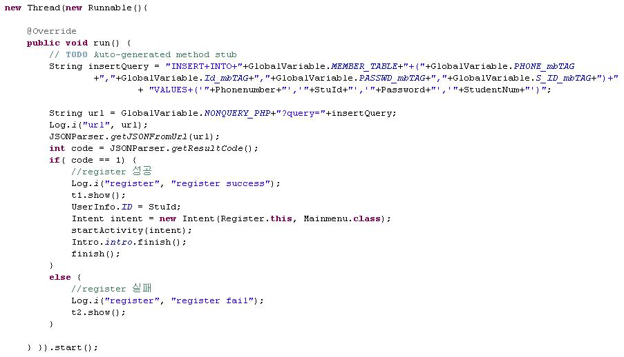

This is the data sending code of Register class. In register class, query string is made with the given variables. Query has the form of url to be given to the php file in the apache server. When url is inserted to the JSONParser, it gives the data to the database and returns resultcode. If resultCode is 1, query input is done safely and execution moves to the Mainmenu activity. Else, register fails and stays at register activity.

1. queryExecutor case

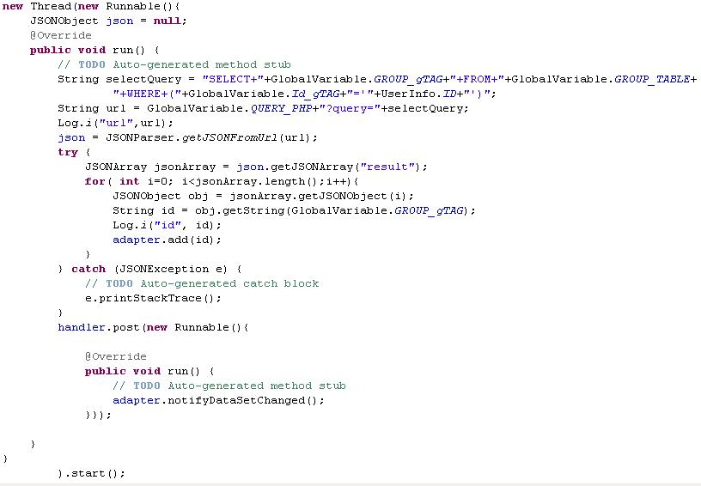

This is the data sending/receiving code of SelectGroup class. In SelectGroup class, query containing userID information is sent to the queryExecutor.php file and group name data is sent back to the application. Data is saved in the jsonArray and it is taken out of the jsonArray with the key of the group name tag. Finally, group name data is set in the Listview.

1. queryExecutor\_login case

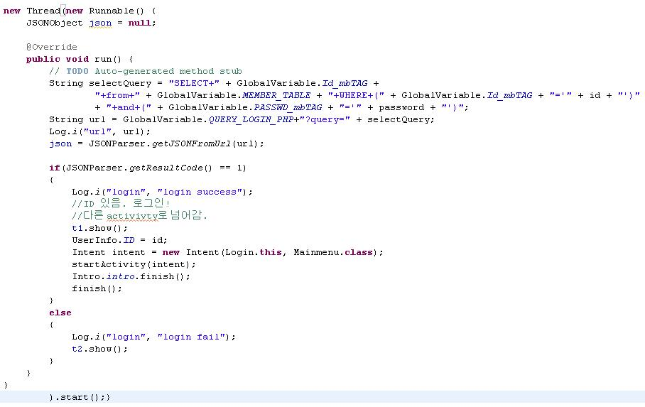

This is the data sending/receiving code of Login class. In Login class, query containing ID information is sent to the queryExecutor\_login.php file and if the ID is in the DB and password matches, Id is sent back to the application. Whether value was returned or not is of importance not the actual value itself. If there is value, value of getResultCode() is 1 since it returns the number of data. In this case, id value is saved in the static ID value in UserInfo class and move to the Mainmenu activity. Otherwise, it gives fail message and stays at that activity.

1. Test Case

|  |  |
| --- | --- |
| Input | Output |
| C:\Users\Su\Dropbox\Software Engineering\UiDesign\UI\13.png | C:\Users\Su\Dropbox\Software Engineering\FINAL!!!!!!!!!!!!!\capture\일괄편집_Screenshot_2013-12-10-23-41-48.bmp |
| C:\Users\Su\Dropbox\Software Engineering\UiDesign\UI\14.png | C:\Users\Su\Dropbox\Software Engineering\FINAL!!!!!!!!!!!!!\capture\일괄편집_Screenshot_2013-12-10-23-42-41.bmp |
| C:\Users\Su\Dropbox\Software Engineering\UiDesign\UI\11.png | C:\Users\Su\Dropbox\Software Engineering\FINAL!!!!!!!!!!!!!\capture\일괄편집_Screenshot_2013-12-10-23-44-44.bmp |
| C:\Users\Su\Dropbox\Software Engineering\UiDesign\UI\7.png | C:\Users\Su\Dropbox\Software Engineering\FINAL!!!!!!!!!!!!!\capture\일괄편집_Screenshot_2013-12-11-00-05-34.bmp |
| C:\Users\Su\Dropbox\Software Engineering\UiDesign\UI\1.png | C:\Users\Su\Dropbox\2013-2\1386766102555.jpg |
| C:\Users\Su\Dropbox\Software Engineering\UiDesign\UI\8.png | C:\Users\Su\Dropbox\Software Engineering\FINAL!!!!!!!!!!!!!\capture\일괄편집_Screenshot_2013-12-10-23-47-27.bmp |
| C:\Users\Su\Dropbox\Software Engineering\UiDesign\UI\6.png | C:\Users\Su\Dropbox\Software Engineering\FINAL!!!!!!!!!!!!!\capture\일괄편집_Screenshot_2013-12-10-23-48-47.bmp |
| C:\Users\Su\Dropbox\Software Engineering\UiDesign\UI\3.png | C:\Users\Su\Dropbox\Software Engineering\FINAL!!!!!!!!!!!!!\capture\일괄편집_Screenshot_2013-12-10-23-49-02.bmp |
| C:\Users\Su\Dropbox\Software Engineering\UiDesign\UI\2.png | C:\Users\Su\Dropbox\Software Engineering\FINAL!!!!!!!!!!!!!\capture\일괄편집_Screenshot_2013-12-10-23-46-52.bmp |
| C:\Users\Su\Dropbox\Software Engineering\UiDesign\UI\9.png | C:\Users\Su\Dropbox\Software Engineering\FINAL!!!!!!!!!!!!!\capture\일괄편집_Screenshot_2013-12-10-23-49-34.bmp |
| C:\Users\Su\Dropbox\Software Engineering\UiDesign\UI\time.png | C:\Users\Su\Dropbox\Software Engineering\FINAL!!!!!!!!!!!!!\capture\일괄편집_Screenshot_2013-12-10-23-49-55.bmp |

1. Trial and Error

**1. Problem** : “If the index is i>j, the shortest path is not appropriately created”

In Tt\_Map\_View class’s subclass Shortestpath class, when index is i>j, the value when i<j is inputted using insertcost method for the link cost of both direction is the same. Find the shortest path cost thorugh allCost method and the shortest path is placed in path array. In this case, when i<j, the shortest path and count is appropriately place but in opposite case, both of them is not appropriately created.

**solution** : “Use the value when index is i<j in case for i>j to solve the problem.”

Path for the case when index is i>j and when i<j is in opposite order and the count value equals. Thus, shortest path when i<j was reversely used for the i>j case and the count was used as it is so that the shortest path can be found even when i>j..

2. problem : “Can Google App Engine can be used as the server for the system??”

Google App Engine is subordinated to the GAE related technologies that specialized knowledge is required. Moreover, data leak and the data stability is known as its flaws.

solution : “Use Apache as the server”

Apache is free, open source program that does not require specialized knowledge. To add on, it is manageable through the personal PC and easily approachable throughout the developing period. Thus, it is appropriate for development exercises.

1. Future Direction

The program can extended to be used nation-wide by the university students if several features are added to the application. If GPS system is incorporated, various maps for different locations will be able to be provided by the application, making different universities to set the map into their location and use it for their own school meetings. If the DB is extended and the planner will be implemented, the system will be able to cover even further number of students, enabling them to check and manage their schedules more efficiently. Moreover, if the alarm system will be incorporated and used to alert the users of different meetings, the utilization of the system will be more productive.

1. Conclusion

The development on software in systematic approach from the documentation to the actual implementation gave a precious experience for the future engineers as developers. First and foremost, importance of documentation that used to be taken for granted due to the actual implementation was highlighted. In handling large projects, prior documentation was indeed necessary guideline that leads the projects into the right direction even in terms of crisis and the documentation afterwards was the needed to allow the developers to see and analyze objectively the final project and think rationally about the future direction of the system. Moreover, the importance of teamwork was learned. Every member of the team had to trust one another both personally and technically for their assigned task for the tem to go on. Works needed to be evenly and efficiently distributed according to member’s strong points and weaknesses and this could be only done if each members know one another well. In the sense of teamwork, the team was very cooperative and efficient handling assigned works with vest efforts and caring one another in times of physical and technical hardness. Like a puzzle that needs to be in exact place to form a beautiful picture, everything from, formation of team, team work, developing environment, technicality and documentation needed to come in hand in hand with equal weights and importance. Not only the application the team developed but also the lesson was the valuable product of the project.